Unit 1 Study Guide (Part 2) Name
The Coordinate System

A coordinate system, or coordinate plane, is used to locate points in a 2-dimensional plane.
- The horizontal number line is the .
- The vertical number line is the .
- Their intersection is the . (Label)
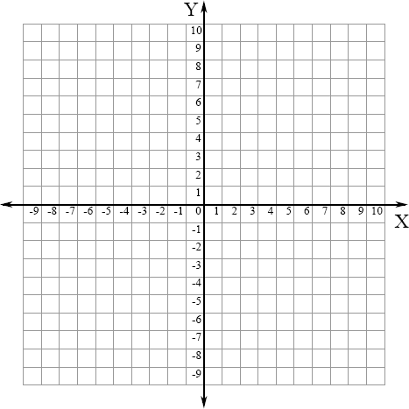
  - The coordinate plane contains four quadrants (I, II, III, IV). Label the quadrants.
  - Any point can be located within one of the four quadrants in the coordinate plane using a specific ordered pair of numbers, called its _.
(x , y)
  - The first number in an ordered pair is the x-coordinate.
  - The second number is the y-coordinate.

Example: (3,2) 3 is the x- coordinate, 2 is the y-coordinate.

A point is defined on the coordinate plane by one, AND ONLY ONE, ordered pair.

Tell what point is located at each ordered pair.

1. (3 , -2)
2. | (2 , 3) | 3. | (-5 , 5)
5. | (-4 , 4) | 6. | (-5 , 0)

4. (-7 , -8)

Write the ordered pair for each given point.

    - E
    - M
    - P

    - G
    - Q
    - N

Plot the following points on the coordinate grid.

13. S (-6,-3) 14. T (2,-4) 15. U (5,8)

Identify the quadrant containing each point.

16. B 17. J 18. I 19. D 20. E

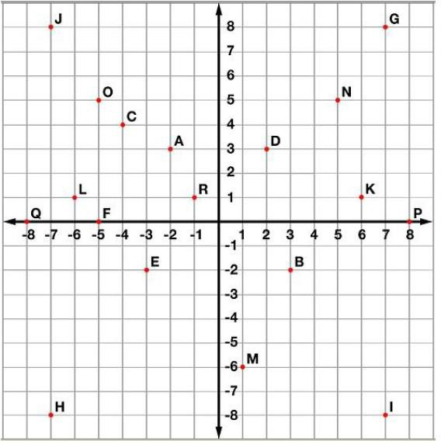
Graph and label the REFLECTION of each point on the coordinate plane

11. N (-1, 3) over x-axis
12. V (2, -4) over y-axis
13. C (4, 0) over x-axis
14. P (-6, 2) over y-axis
15. M (-5, 0) over x-axis

