NAME:________________________________________ Probability of Simple Events HW

A card is randomly chosen. Find each probability. Write
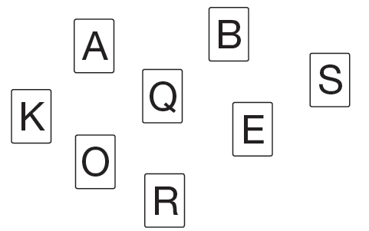
each answer as a fraction, a decimal, and a percent.
1. P(B)

2. P(Q or R)

3. P(vowel)

4. P(consonant or vowel)

5. P(consonant or A)

6. P(T)

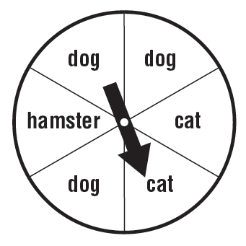
The spinner shown is spun once. Determine if each event is
impossible, unlikely, equally likely, likely, or certain.

7. P(dog)

8. P(hamster)

9. P(dog or cat)

10. P(bird)

11. P(mammal)

