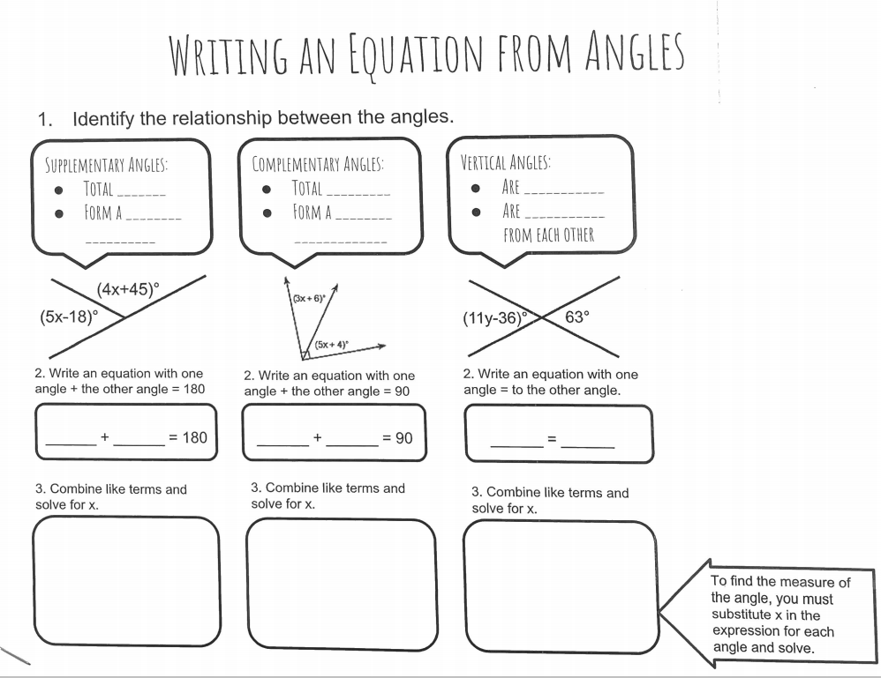
Angle Relationships
Name the angle relationship, find x, and identify the missing angle measure in each problem.
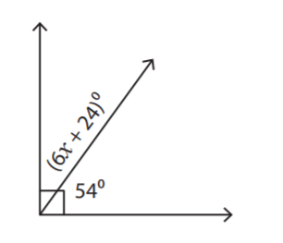  Angle Relationship: ____________________________  Equation:  x = _______  Missing angle measure: | 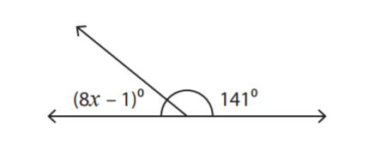  Angle Relationship: ____________________________  Equation:  x = _______  Missing angle measure:
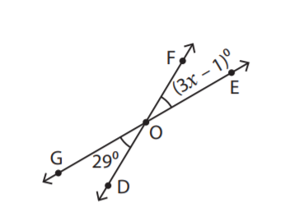  Angle Relationship: __________________________  Equation:  x = _______  Missing angle measure: | 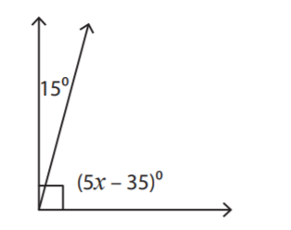  Angle Relationship: __________________________  Equation:  x = _______  Missing angle measure:

Name the angle relationship, find x, and identify the missing angle measure in each problem.
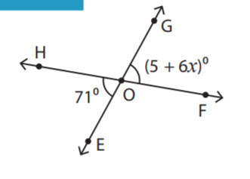  Angle Relationship: ____________________________  Equation:  x = _______  Missing angle measure: | 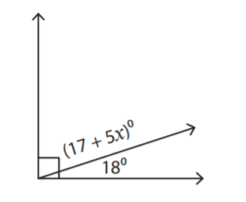  Angle Relationship: ____________________________  Equation:  x = _______  Missing angle measure:
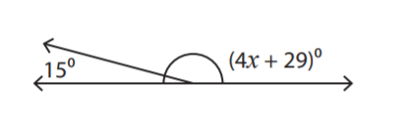  Angle Relationship: __________________________  Equation:  x = _______  Missing angle measure: | 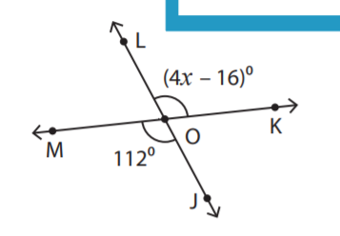  Angle Relationship: __________________________  Equation:  x = _______  Missing angle measure:

