SURFACE AREA
Surface Area: sum of all the areas of all the surfaces (faces) of a three-dimensional figure; example: amount of wrapping paper needed to cover a box; surface area is in squared units
Complete the F-A-T table to calculate the surface area of each geometric solid. Show all work. Include labels with your answers.
Rectangular Prism
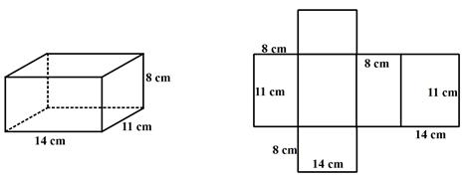

FACES | AREA | TOTAL

TOTAL SURFACE AREA: ______________________________________________________________
FACES | AREA | TOTAL

Triangular Prism
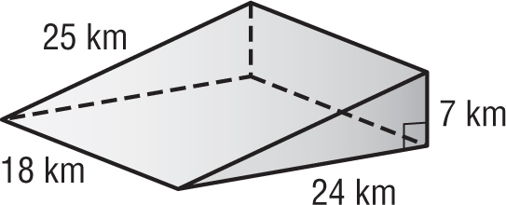

TOTAL SURFACE AREA: ______________________________________________________________
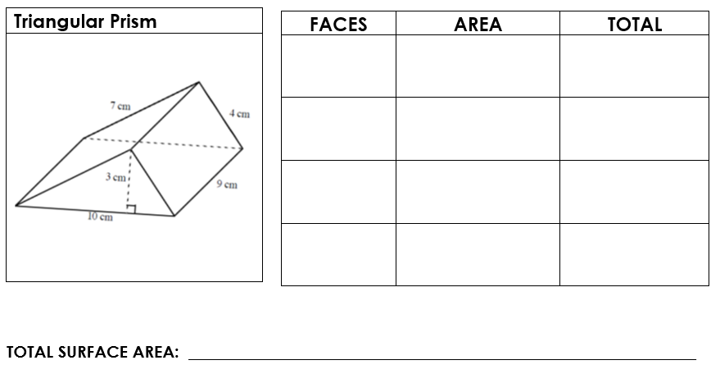
Rectangular Prism
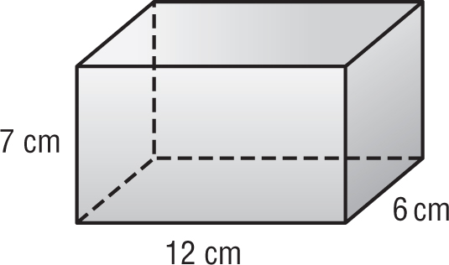
FACES | AREA | TOTAL

TOTAL SURFACE AREA: ______________________________________________________________

YOUR TURN:
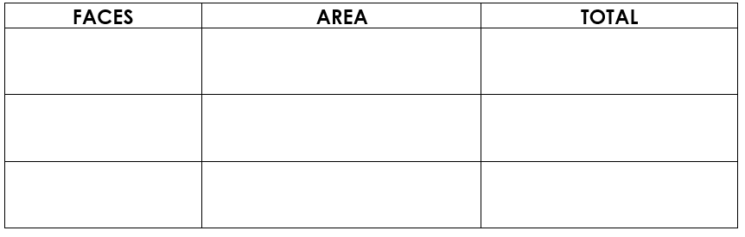
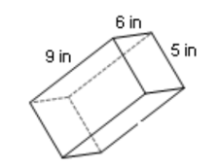

FACES | AREA | TOTAL

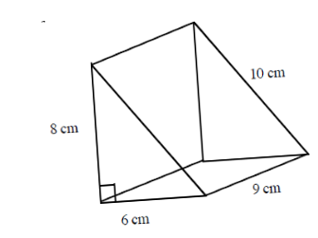

FACES | AREA | TOTAL

