**DATA DISPLAYS**

**Line Plot (dot plot):** a visual display of a distribution of data values where each data value is shown as a dot or other mark, usually an X, above a number line.

**Histogram:** a type of bar graph used to display numerical data that have been organized into equal intervals; the bars touch; all bars have the same width

**Outlier:** a data value that is either much greater or much less than the median

**Draw a histogram to represent the set of data. Include a title and label the axes.**

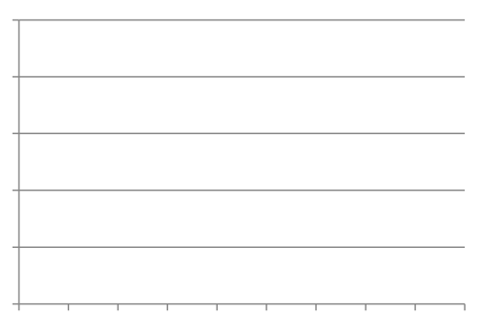

|  |  |  |
| --- | --- | --- |
| **Lengths of Snakes** | | |
| **Length (in.)** | **Tally** | **Frequency** |
| 12–23 | |||| |||| | 10 |
| 24–35 | |||| |||| | 10 |
| 36–47 | |||| || | 7 |
| 48–59 | |||| | 5 |
| 60–71 | |||| | 4 |

How many snakes are at least 36 inches long?

_______ snakes

How many more snakes are 12 – 35 inches long than 60 – 71 inches long?

_______ snakes

**Make a line plot for the set of data. Find the median, mode, range, and any outliers of the data.**

Student Height (in inches) for Mrs. Foster’s 5th Grade Class

**48 42 48 43 47 60 45 48 49 42**

**Student Height (in inches)**



|  |  |
| --- | --- |
| **MEDIAN** | **MODE** |
| **RANGE** | **OUTLIER?** |

A **box-and-whisker plot** uses the least and greatest data values along with three special midpoints to represent how the data is spread out.

**Interquartile range** (IQR): distance between the lower quartile and the upper quartile; subtract the lower quartile from the upper quartile ()

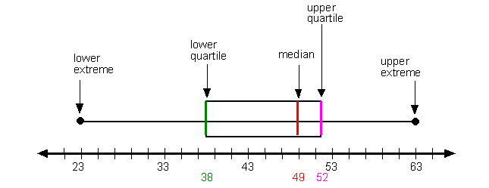

Each whisker and each part of the box represents 25% of the data values – REGARDLESS OF THE SIZE OF THE WHISKERS AND SECTIONS OF THE BOX.

The longer the whisker or part of the box, the more spread out the values are.

If a whisker or part of the box is short, it means the data values represented are close together.

Draw a box-and-whisker plot of the data. **39 41 30 14 44 41 50 39 42 36**

**ORDER DATA:**

Lower Extreme : ________

Lower Quartile : ________

Middle Quartile : ________

Upper Quartile : ________

Upper Extreme : ________

Interquartile range (IQR):

__________________________

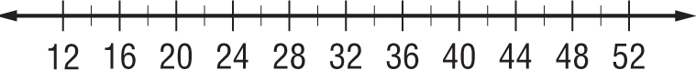

1. What is the median of the data? _________

2. What percent of the data is greater than 36? ________%

Listed below are the heights of boys on an 8th grade basketball team. Draw a box-and-whisker plot of the data. Include a title. **60 66 70 72 71 68 60 67 70 77 66 66 67**

**ORDER DATA:**

Lower Extreme : ________

Lower Quartile : ________

Middle Quartile : ________

Upper Quartile : ________

Upper Extreme : ________

Interquartile range (IQR):

__________________________

1. What is the median of the data? ____________

2. What percent of the players are at least 68 inches tall? _______%