

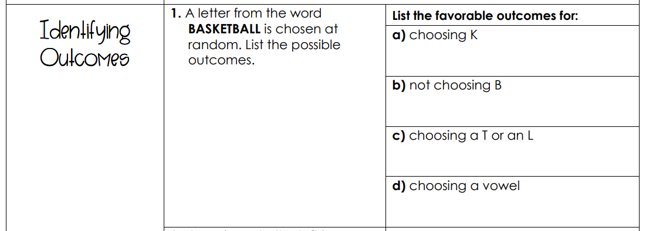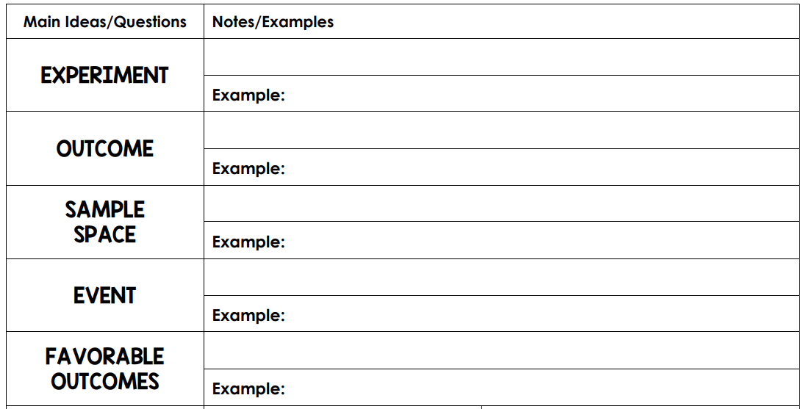

Rolling an odd number – {1,2,3} 

Rolling an odd number 

One dice - {1,2,3,4,5,6} A coin – {H,T}

A coin landing on heads 

Flipping a coin. Rolling a dice. Spinning a spinner 

The outcome you are looking for in an experiment 

One or more outcomes of an event 

ALL possible outcomes of an experiment

A possible result of an experiment. 

An activity with an observable result.

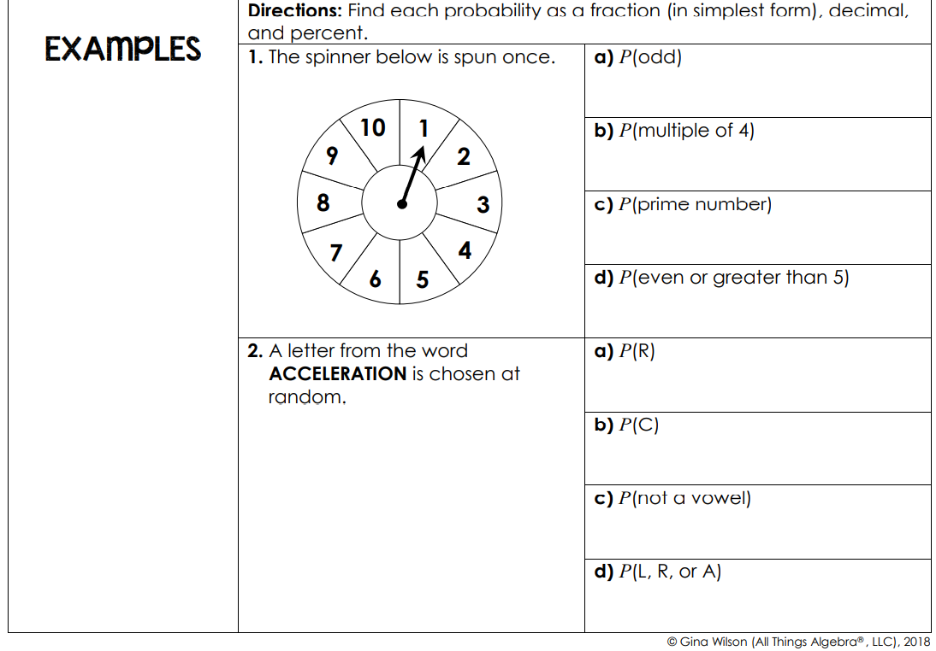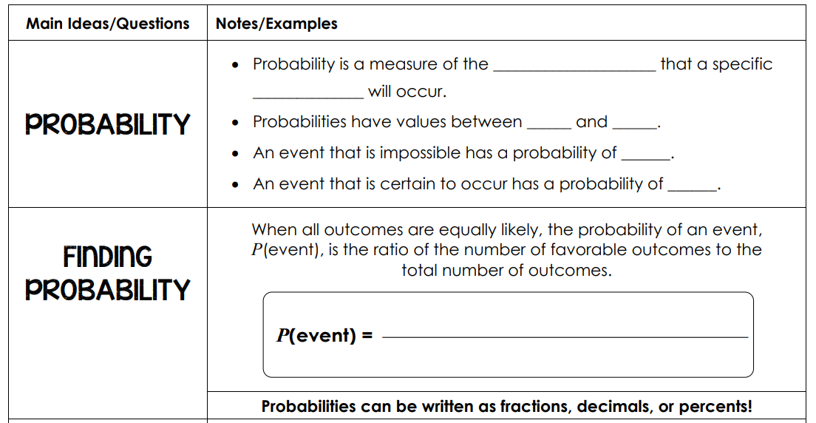

Total # of outcomes

# of favorable outcomes

1

0

1

0

kelihood 

event 

likelihood 

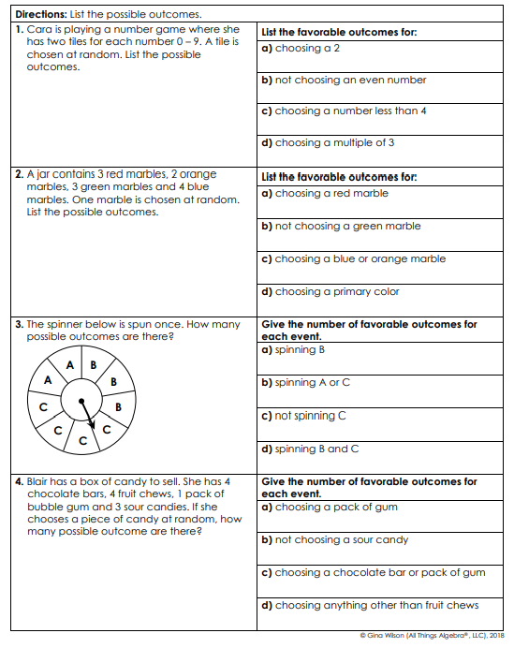

Write the probabilities for each event as a fraction, decimal and percent.

