NAME: _______________________________ Geometry Part 3B Test Study Guide

1. Determine if the angles below form a triangle. Show your work. State YES or NO on the line.  95°, 7°, 78°  ____________ | 2. Determine if the angles below form a triangle. Show your work. State YES or NO on the line.  116°, 9°, 60°  ____________
3. Write and solve the equation to find the value of the missing angle. SHOW YOUR WORK.  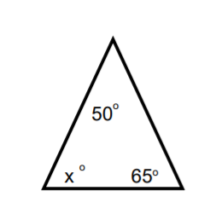  ________ degrees | 4. Write and solve the equation to find the value of x. SHOW YOUR WORK.  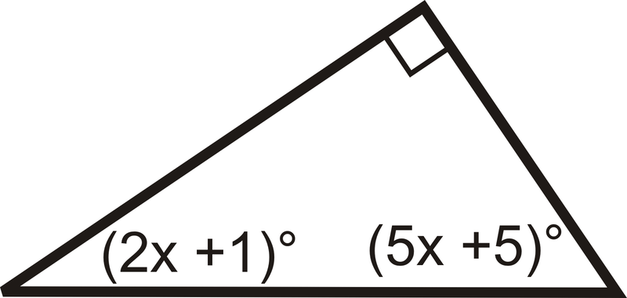  ________ degrees
5. Write and solve the equation to find the value of the missing angle. SHOW YOUR WORK.  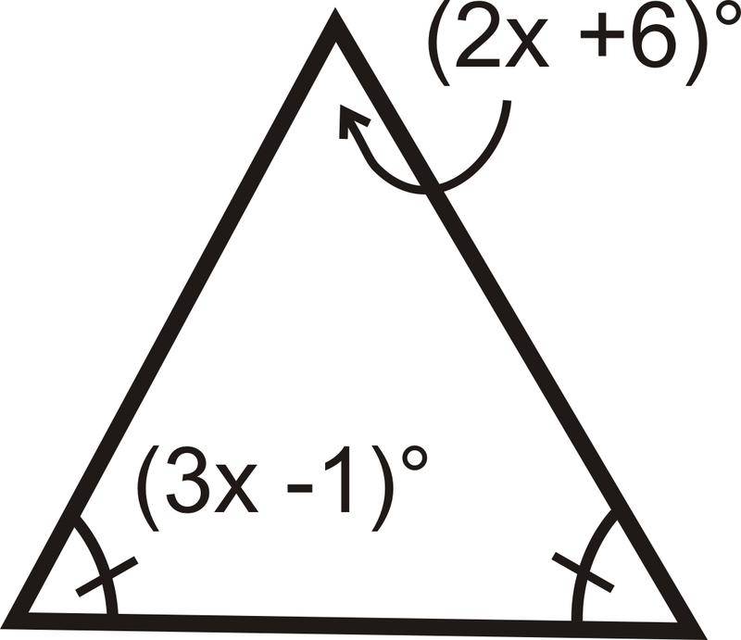 Missing Angle  ________ degrees | 6. Using the Triangle Inequality Theorem, determine if these sides form a triangle. SHOW YOUR WORK.  1, 5, 1  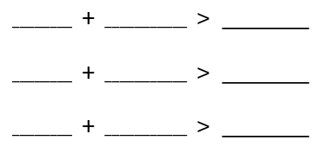  Do the sides form a triangle? ________
7. Find the range of lengths for the third side of the triangle using the lengths of the other two sides  7 ft and 13 ft  RANGE: ___________ < x < __________ | 8. What would be the cross section of a rectangular prism that is sliced vertically?  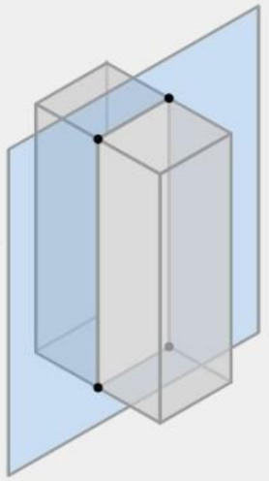  A.) rectangle  B.) triangle  C.) pentagon  D.) trapezoid
9. Identify the shape of the cross section.  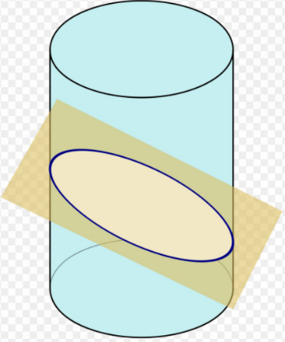  A.) rectangle  B.) ellipse  C.) triangle  D.) trapezoid | 10. What would be the cross section of a cone that is sliced horizontally?  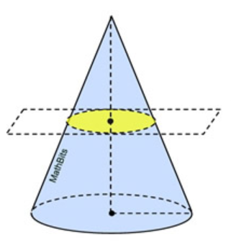  A.) rectangle  B.) ellipse  C.) triangle  D.) circle
11. What is the classification of the triangle by its angles?  A.) obtuse  B.) right  C.) acute  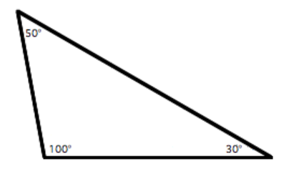 | 12. What is the classification of the triangle by its sides?  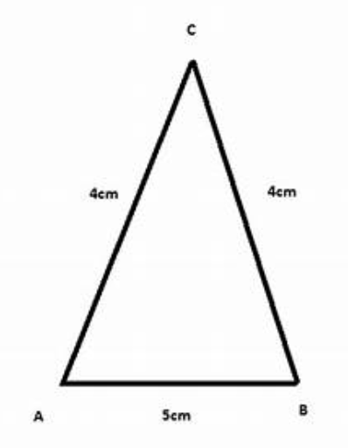  A.) equilateral  B.) scalene  C.) isosceles
13. What is the classification of the triangle by its angles and by its sides?  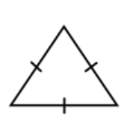  A.) acute, equilateral  B.) right, equilateral  C.) obtuse, isosceles  D.) obtuse, equilateral | 14. What is the classification of the triangle by its angles and by its sides?  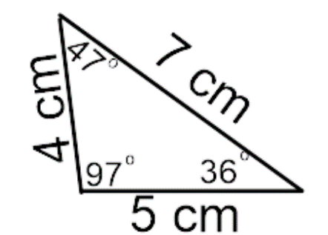  A.) acute, isosceles  B.) right, equilateral  C.) obtuse, scalene  D.) right, scalene

