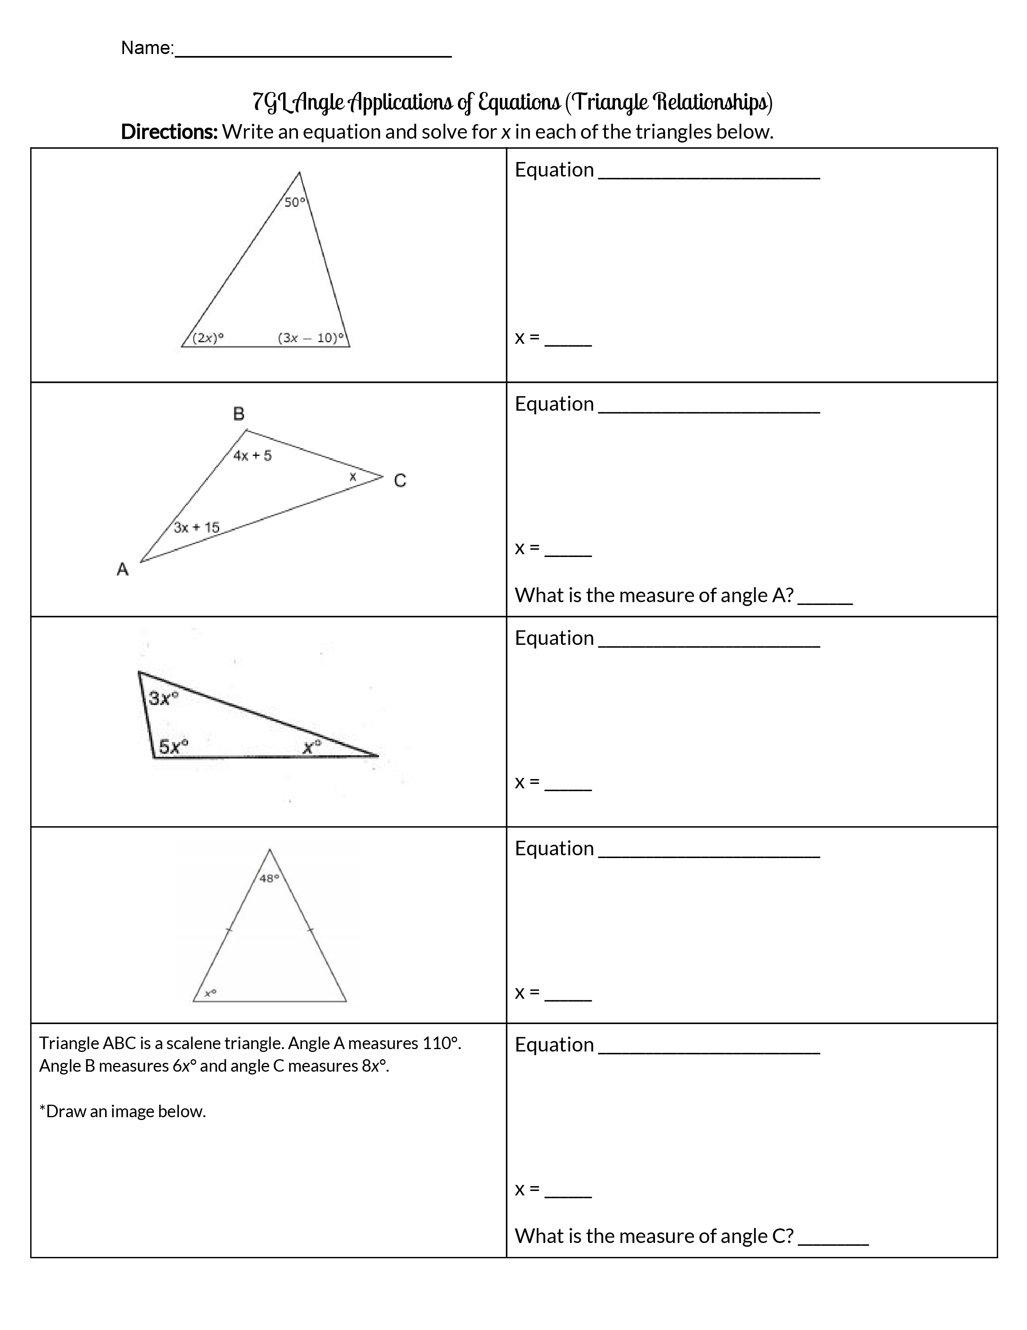

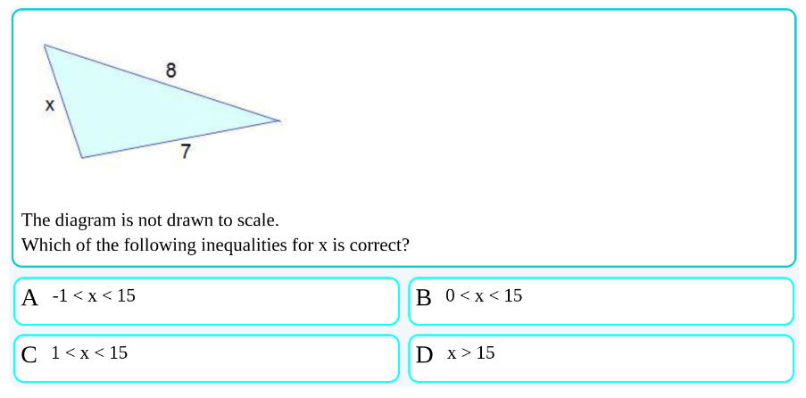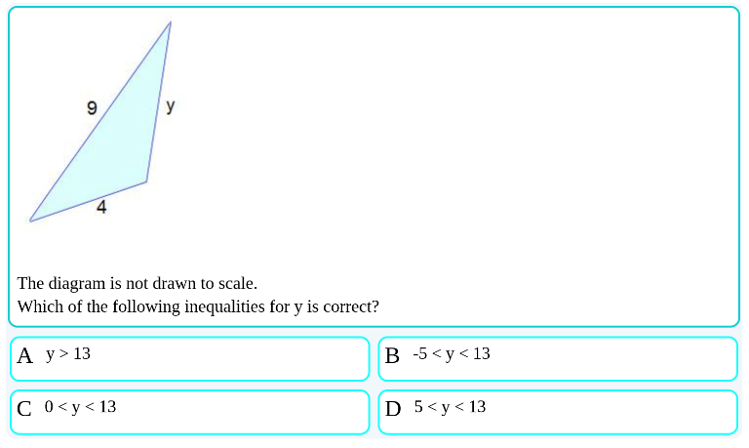
Find the range of lengths for the third side of the triangle using the lengths of the other two sides (show your work on the righthand side):
7ft
13ft
4mm 7mm
12ft
9ft
10m
4m
8in
21in
2.5cm
3.2cm

