All measurements for the grid are in inches. You must write the correct unit of measure.
Circumference | 34 in
Area | 2.7 in²
Area | 9 in²
Circumference | 10.3
Area | 4 in²
Circumference | 7
Circumference | 31
Area | 95.3
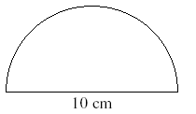
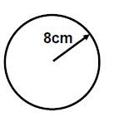
Diameter |  | Diameter
Radius |  | Radius
Circumference |  | Circumference | xxxxxxxxxxxxxxxxxx
Area |  | Area
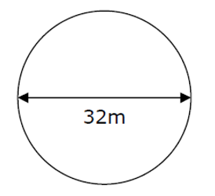
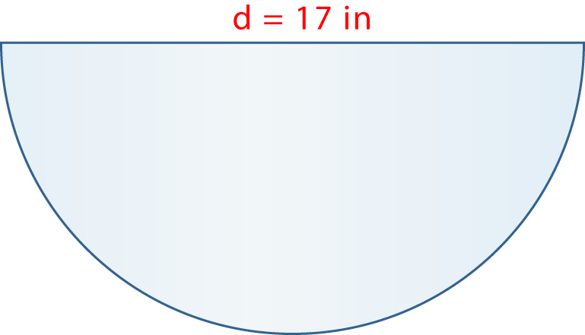
Diameter |  | Diameter
Radius |  | Radius
Circumference | xxxxxxxxxxxxx | Circumference
Area |  | Area

Mary wants to cover the top of a circular pillow with fur. The pillow has a radius of 8.5 inches. What amount of fur will she need to buy?

