Name: ________________________________________________ Geometry Part 2 Test Study Guide
Standard to be Assessed: MGSE7.G6 Solve real-world and mathematical problems involving area, volume, and surface area of two- and three-dimensional objects composed of triangles, quadrilaterals, polygons, cubes, and right prisms.
You may find the following formulas helpful:
Area of a Square or Rectangle: $A=lw$ or $A=bh$ Area of a Triangle: $A= \frac{bh}{2}$ or $A=0.5bh$
Volume of Rectangular Prism: $V=lwh$ Volume of Triangular Prism: $V= \frac{lwh}{2}$

Find the volume of each prism. Show all work. Include units of measurement with your answers.
1. Hint: Rewrite as mixed decimals by converting the fractions to decimals (divide the numerator by the denominator.)  Volume: ________________ | 2.  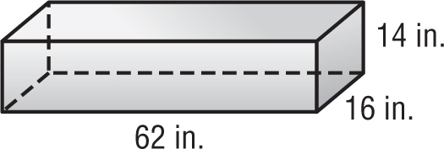  Volume: ________________
3.  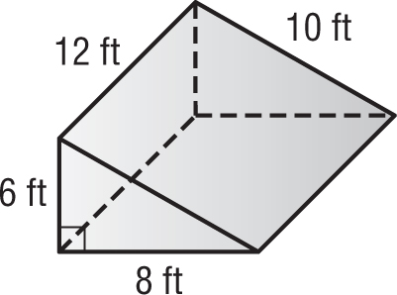  Volume: ________________ | 4.  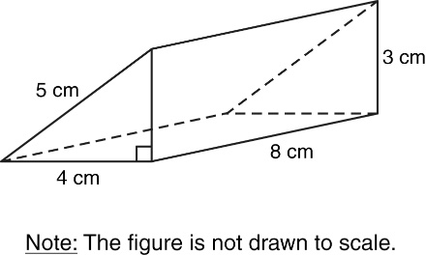  Volume: ________________
5.  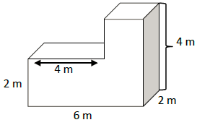  Volume: ________________ | 6.  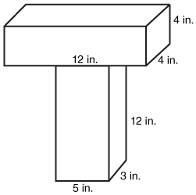Volume: ________________

For #7 – 9, complete the F-A-T table to calculate the surface area of each prism. Show all work. Include units of measurement with you answers.
Faces | Area | Total
Triangle 1
Triangle 2
Rectangle 1
Rectangle 2
Rectangle 3
7.

Total Surface Area: __________________________________________

Faces | Area | Total
Front & Back
Top & Bottom
Side/Side
8.
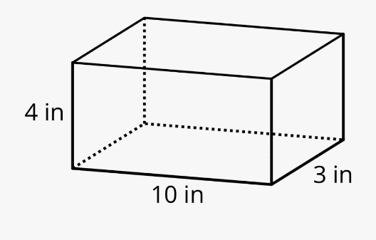

Total Surface Area: __________________________________________
Faces | Area | Total
Triangle 1
Triangle 2
Rectangle 1

Rectangle 2

Rectangle 3
9.

Total Surface Area: __________________________________________

