COMPARING DOT PLOTS
DOT PLOTS | A dot plot displays data ________________using a small dot or X for each data piece.  The data points are ____________________ from least to greatest.
SHAPE | Data can take on three different shapes:  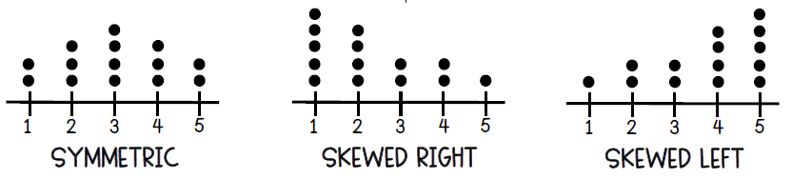
SPREAD | The variability or spread in the data points describes how far apart the data is from one  another. This can also be represented by the ________________________.
CENTER | The median and the mean both represent the center of the data.  - When the data is skewed, then the _________________ is the best representation of the data.  - When the data is symmetric, then the ________________ is the best representation of the data.

The number of TVs per household for Mrs. Jamison’s class and Mr. Zimmerman’s class are shown below.
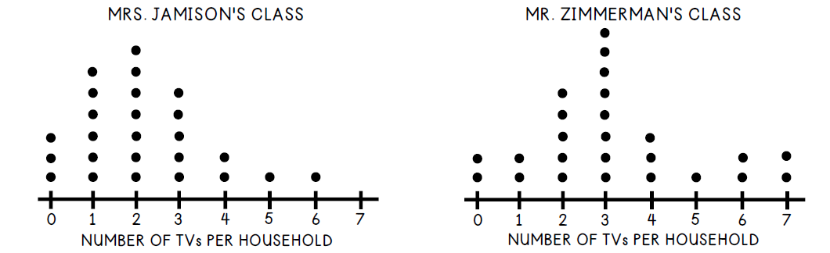
What is the median number of TVs in Mrs. Jamison’s class? | What is the median number of TVs in Mr. Zimmerman’s class?
What is the range in number of TVs per household in Mrs. Jamison’s class? | What is the range in number of TVs per household in Mr. Zimmerman’s class?
Mark each statement below as TRUE or FALSE.

_______ The range of the number of TVs per household in Mrs. Jamison’s class is less than the range of the number of TVs per household in Mr. Zimmerman’s class.

_______ The median number of TVs per household is equal in both Mrs. Jamison’s class and Mr. Zimmerman’s class.

_______ The mode number of TVs per household for both Mrs. Jamison’s class and Mr. Zimmerman’s class is 3.

Looking at the data above, which class is more likely to have the higher mean (average) number of Tv’s? Why?

COMPARING BOX PLOTS
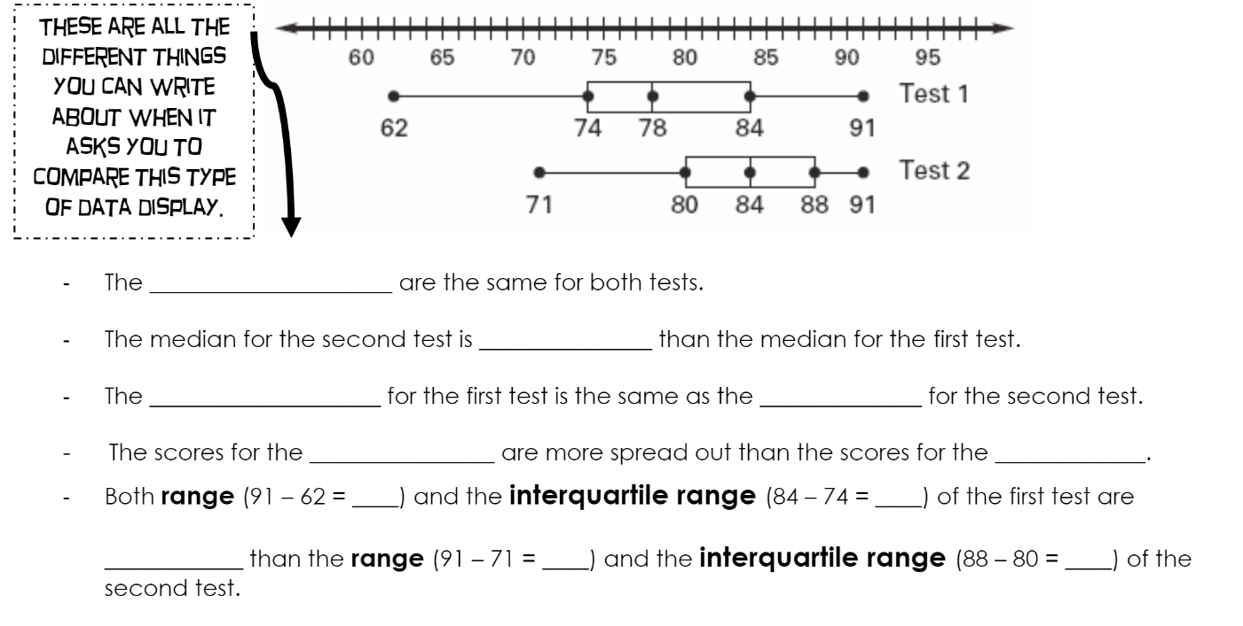
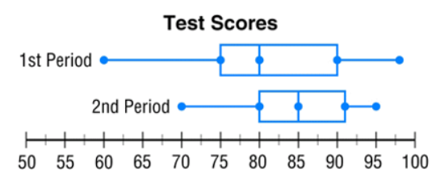 | Which period had the higher MEDIAN? _____________  What percent of 1st period scored an 80 or above? ________  What percent of 2nd period scored an 80 or above? ________  Which of the two classes performed better overall? Make at least two comparison statements to justify your choice.

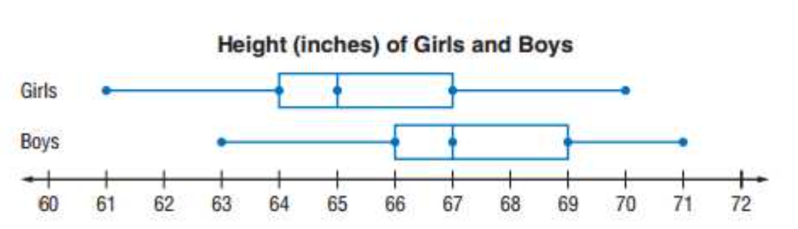 | Make a comparison statement about the median height of girls versus boys.  What percent of girls are 67 inches or less? __________  What percent of boys are 67 inches or less? _________

