NAME: _______________________________________ Circles Quiz Review HW
You may find the following formulas helpful on this assignment:
Area of a Circle: $A= π∙r ∙r$ Area a Semi-circle: $A= \frac{π ∙ r ∙ r}{2}$
Circumference of a Circle: $C= π∙d$

1. If the radius of a circle is 11 feet, what is the length of the diameter?  _______feet | 2. If the diameter of a circle is 24 centimeters, what is the length of the radius?  ______ centimeters
3. Find the circumference of the circle. Use 3.14 for pi. Show your work. Include a label with your answer.  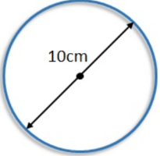  Circumference = __________________________ | 4. During a senate campaign, a volunteer passed out a "Vote for Peterson" button. The campaign button has a radius of 4 centimeters. What is the button's circumference? Use 3.14 for pi. Show your work. Include a label with your answer. HINT: Find the length of the diameter first.  Circumference = ______________________________
5. Find the area of the circle. Use 3.14 for pi. Show your work. Include a label with your answer.  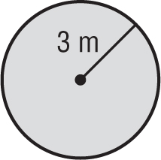  Area = _______________________________ | 6. Patricia buys a round dinner table. The diameter of the dinner table is 4 feet. What is the area of the table? Use 3.14 for pi. Show your work. Include a label with your answer. HINT: Find the length of the radius first.  Area = ____________________________________
7. Find the area of the semi-circle whose diameter is 15 feet. Use 3.14 for pi. Show your work. Include a label with your answer. HINT: Find the length of the radius first.  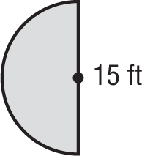  Area = __________________________________ | 8. A semi-circle shaped rug has a radius of 2 ft. What is the area of the rug? Use 3.14 for pi. Show your work. Include a label with your answer.  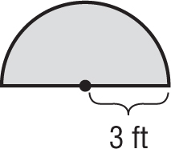  2 ft  Area = ____________________________________

