AREA OF SHADED REGIONS
How to find the area of a shaded region….
- Separate it into figures with areas you know how to find.
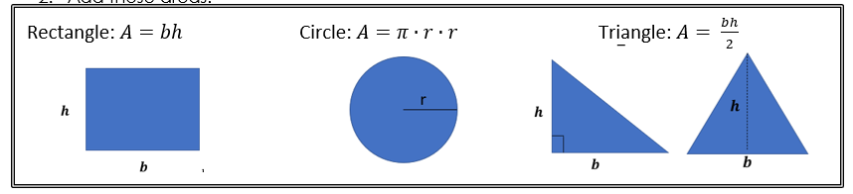
- Subtract those areas.

Find the area of the shaded region.
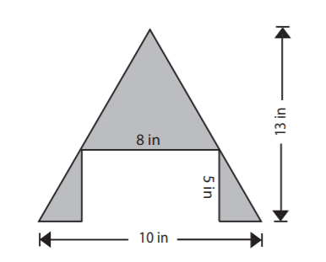  Area of Shaded Region: _____________________ | 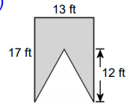  Area of Shaded Region: _____________________
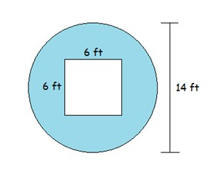  Area of Shaded Region: _____________________ | 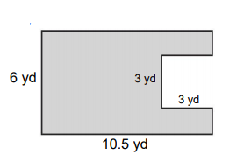  Area of Shaded Region: _____________________
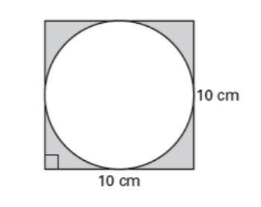  Area of Shaded Region: _____________________ | 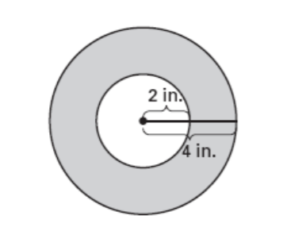  Area of Shaded Region: _____________________

