Semi-Circles & Circle Word Problems
AREA OF A SEMI-CIRCLE (half of a circle)
$Area= \frac{π∙r∙r}{2}$ or $\frac{1}{2}π∙r∙r$
Reminder: Area is always in squared units (examples: ${inches}^{2}, {feet}^{2}, {centimeters}^{2}$)

Find the area of each semi-circle. Use 3.14 for $π$. Show your work. Include a label with your answer.
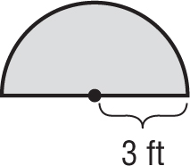 | 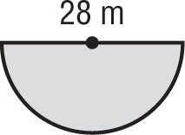
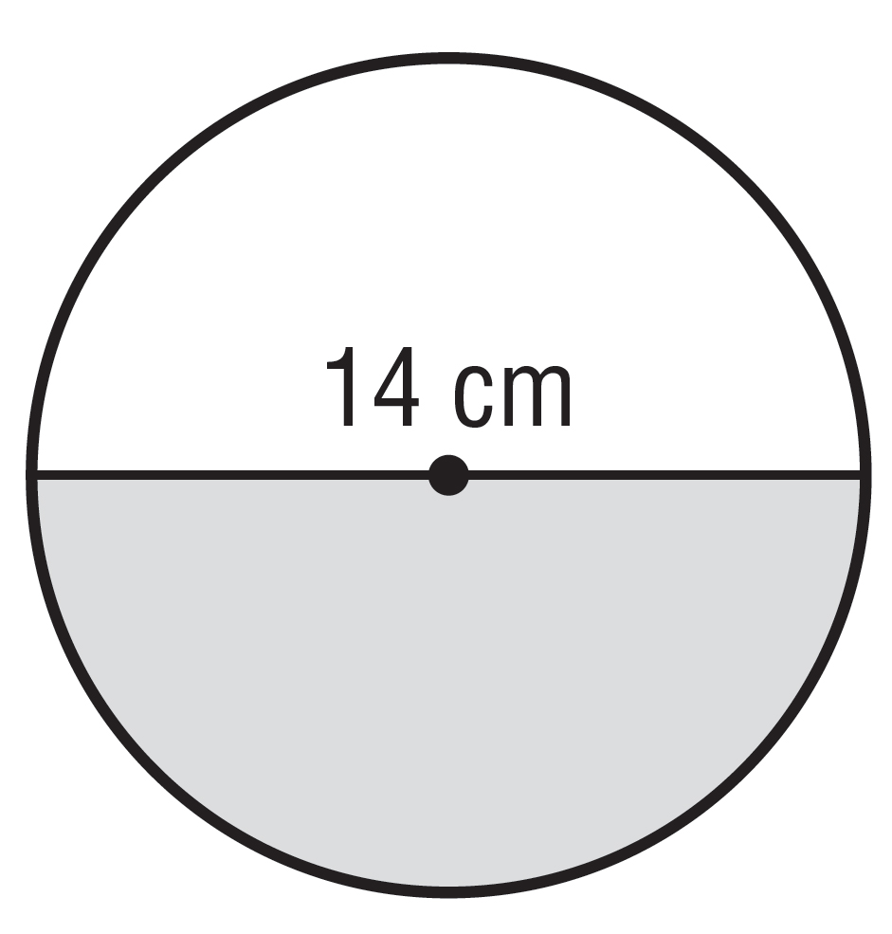 | 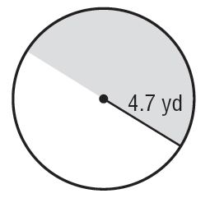
CIRCUMFERENCE  $$C=πd$$  or  $$C=2πr$$  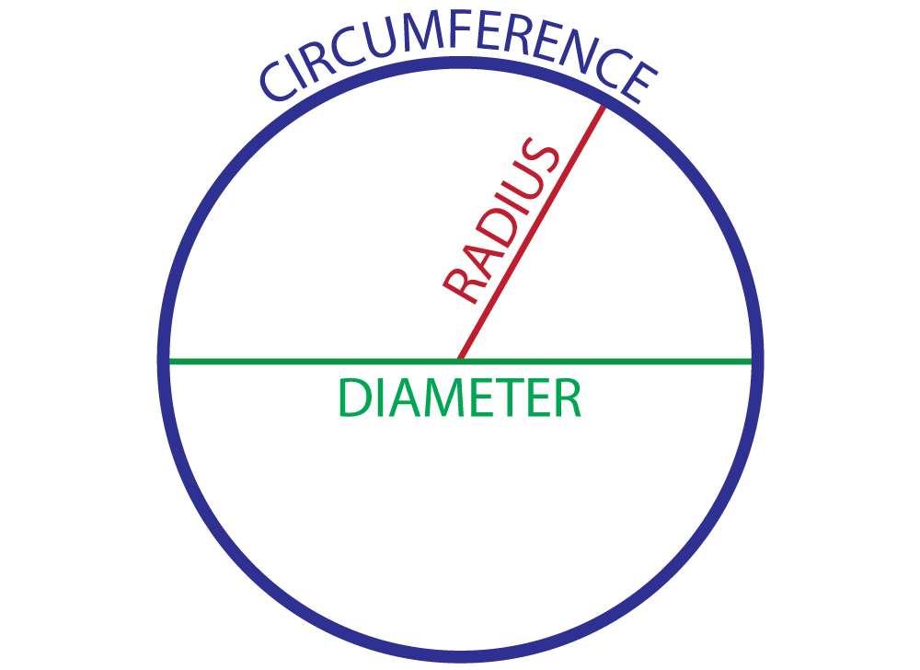 | AREA  $$A=π∙r∙r$$  or  $$A=πr^{2}$$  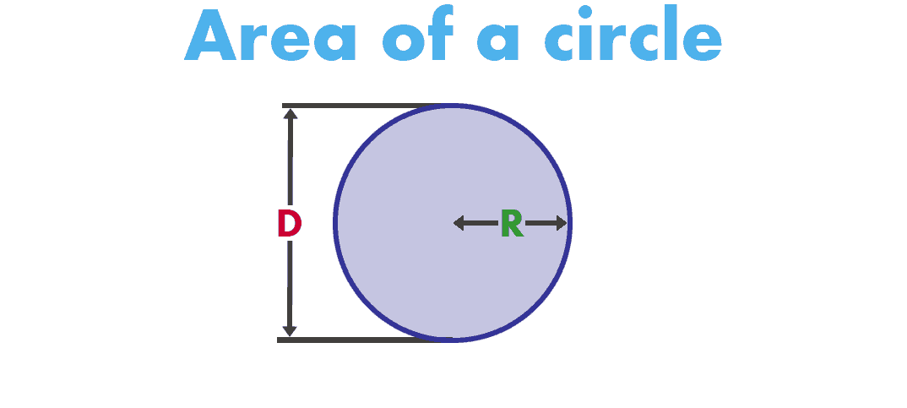

Read each problem carefully. Use 3.14 for $π$. Show your work. Round your answer to the nearest tenth. Include a label with your answer.
Susan has a circular swimming pool. The  pool has a diameter of 26 feet. Find the  circumference of the pool. | What is the area of the drumhead on the  drum shown below?  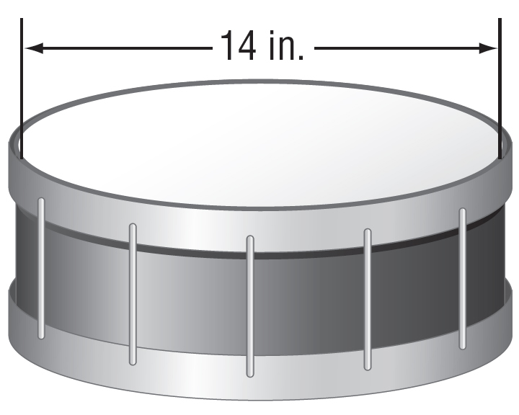
Victor needs to buy mulch for the garden with the dimensions shown in the figure. For how much area does Victor need to buy mulch?  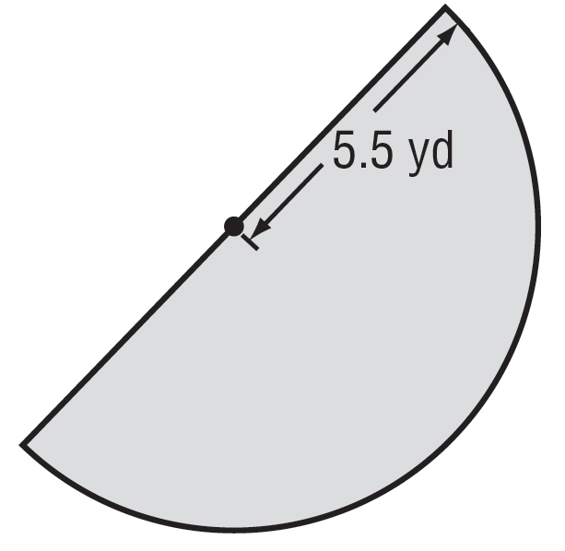 | A bicycle wheel has a radius of 10.5 inches. What is the circumference of the wheel?

