AREA OF COMPOSITE FIGURES
How to find the area of a composite figure….
- Separate it into figures with areas you know how to find.
- Add those areas.
Rectangle: $A=bh$ Circle: $A=π∙r∙r$ Triangle: $A= \frac{bh}{2}$

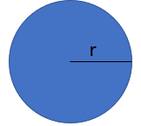
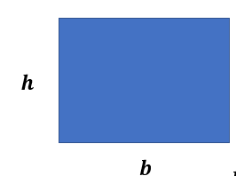

Find the area of each figure.
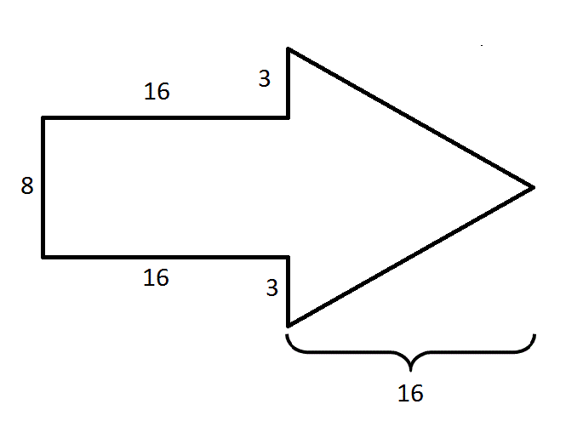  Total Area: _________________________ | 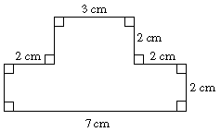  Total Area: _________________________
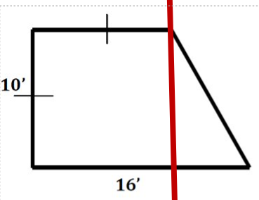  Total Area: _________________________ | 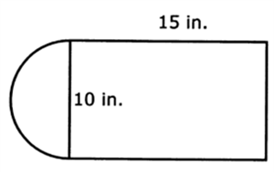  Total Area: _________________________
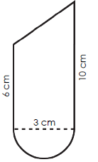  Total Area: _________________________ |  | 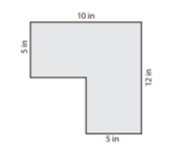  Total Area: _________________________
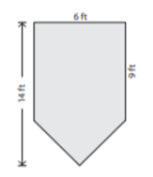  Total Area: _________________________ |  | 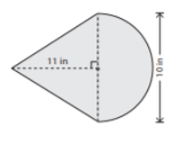  Total Area: _________________________
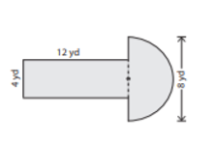  Total Area: _________________________ |  | 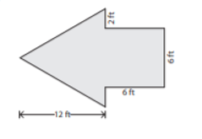  Total Area: _________________________

